**DSD ASSIGNMENT**

Code coverage for Debouncing and Fibonacci Numbers with FSM-D

By: C.P.Sindhu(PES1UG21EC071) Amogh S. Rao(PES1UG21EC033) Saksham Singh(PES1UG21EC240) Akhat VA (PES1UG21EC018)

1. Debouncing Circuit with FSM-D

State diagram:

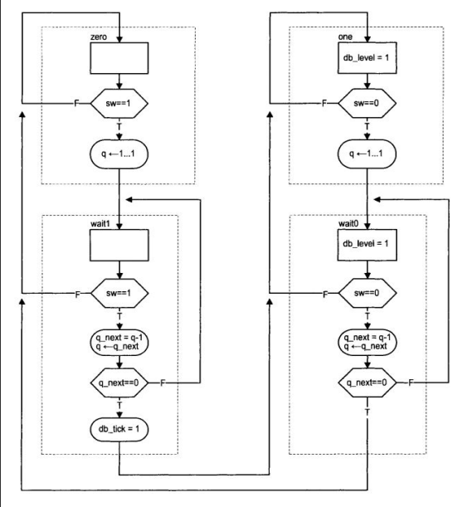

Code:

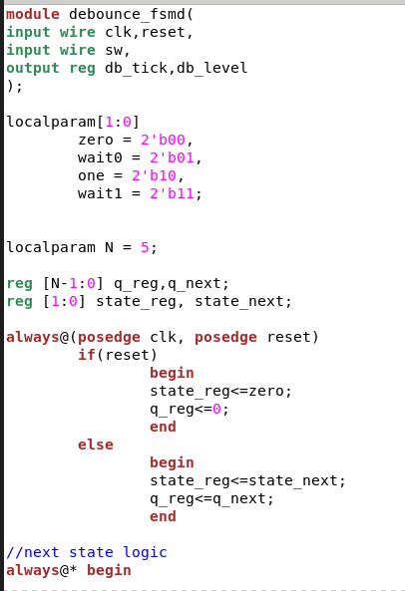

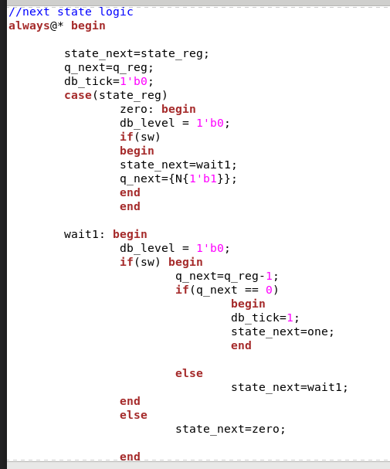

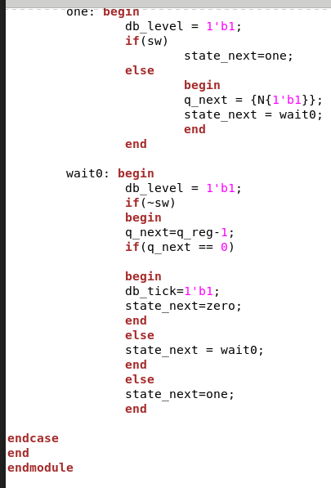

TestBench Code:

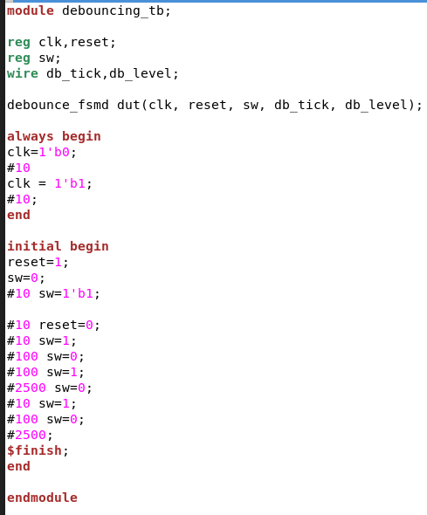

Output:

Waveform:

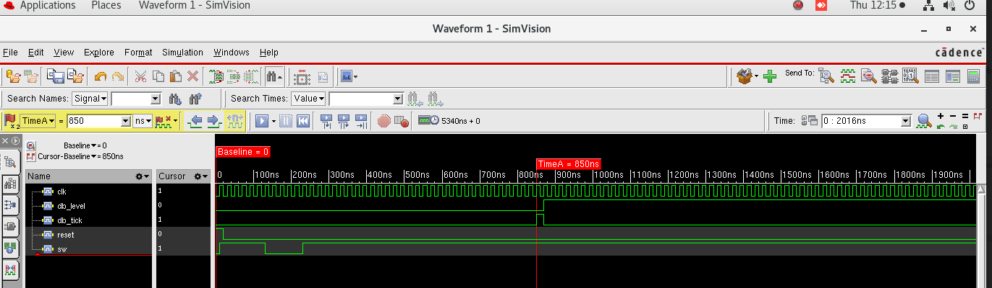

Code Coverage:

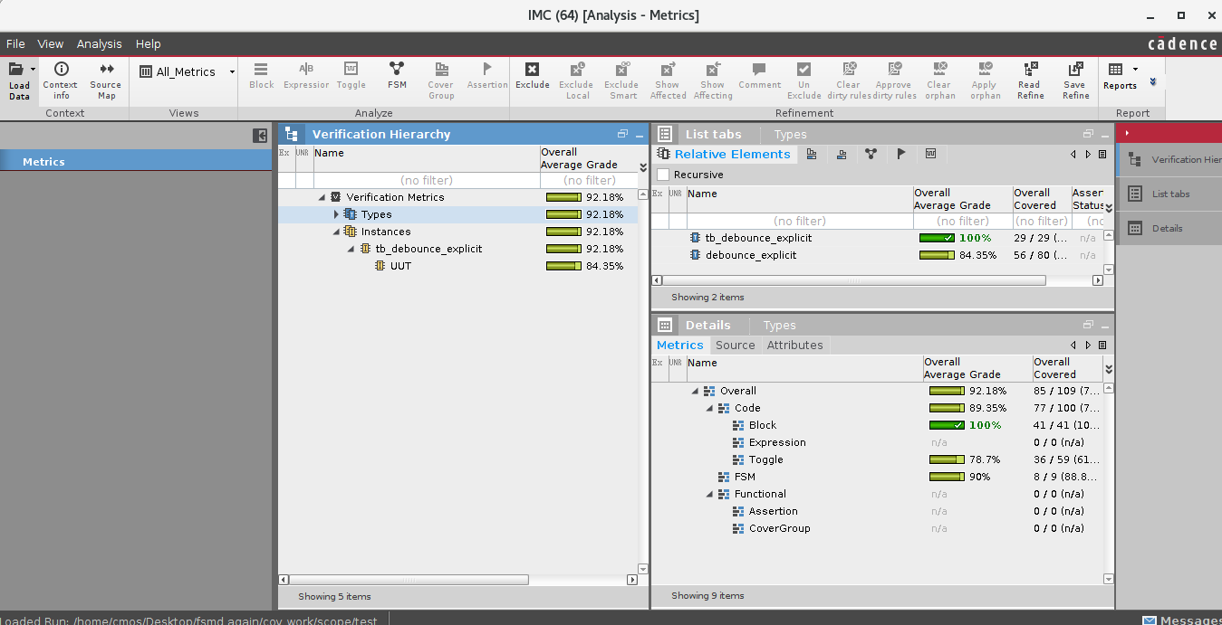

1. Fibonacci Numbers with FSM-D

State diagram:

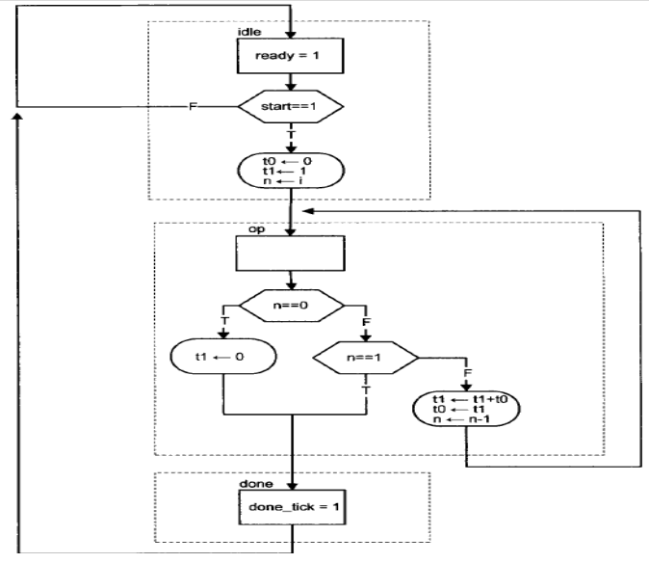

Code:

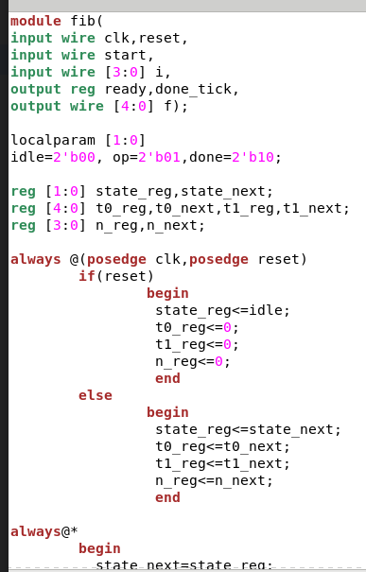

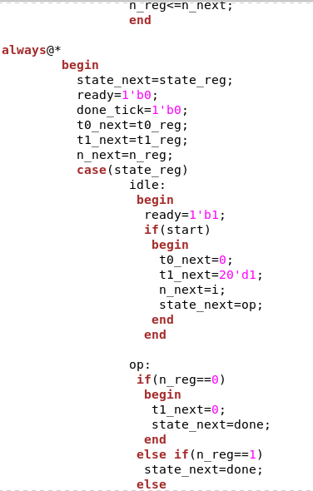

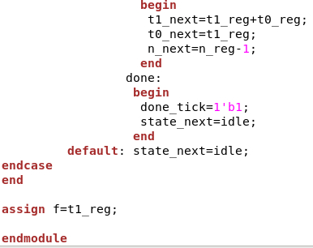

Testbench code:

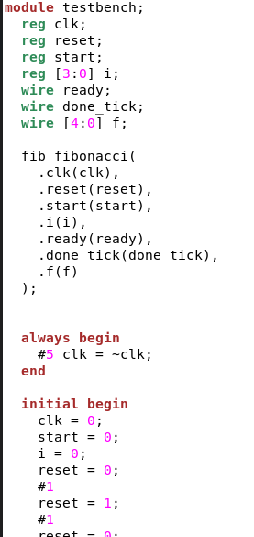

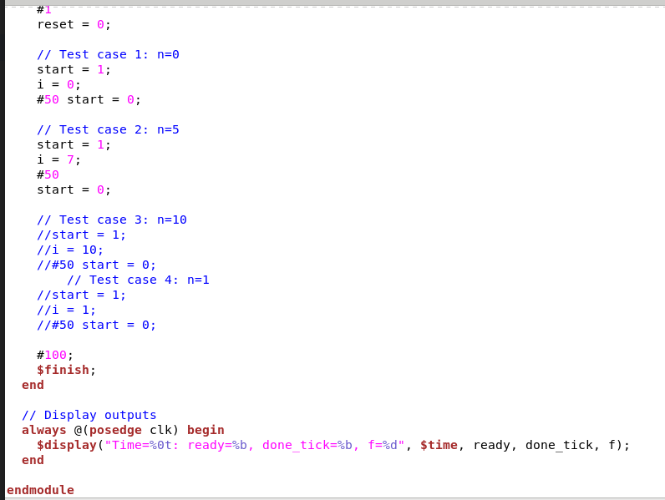

Output:

Waveform:

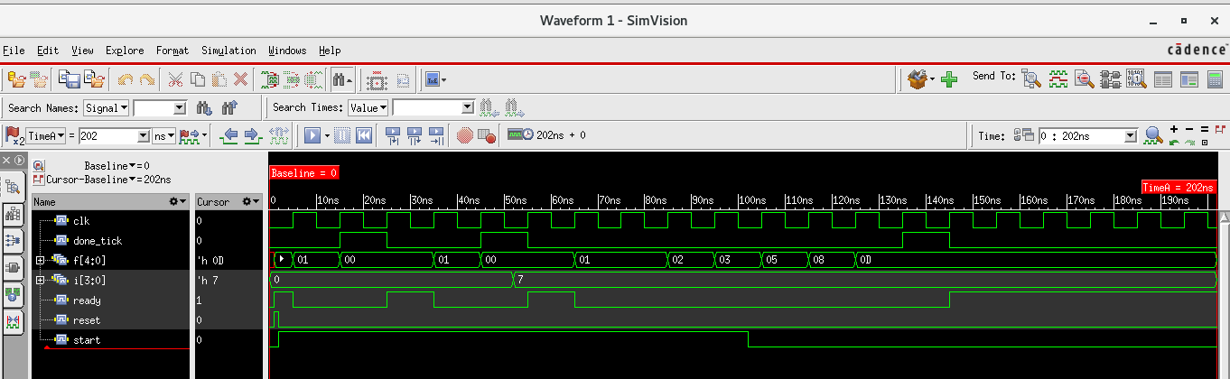

Code Coverage:

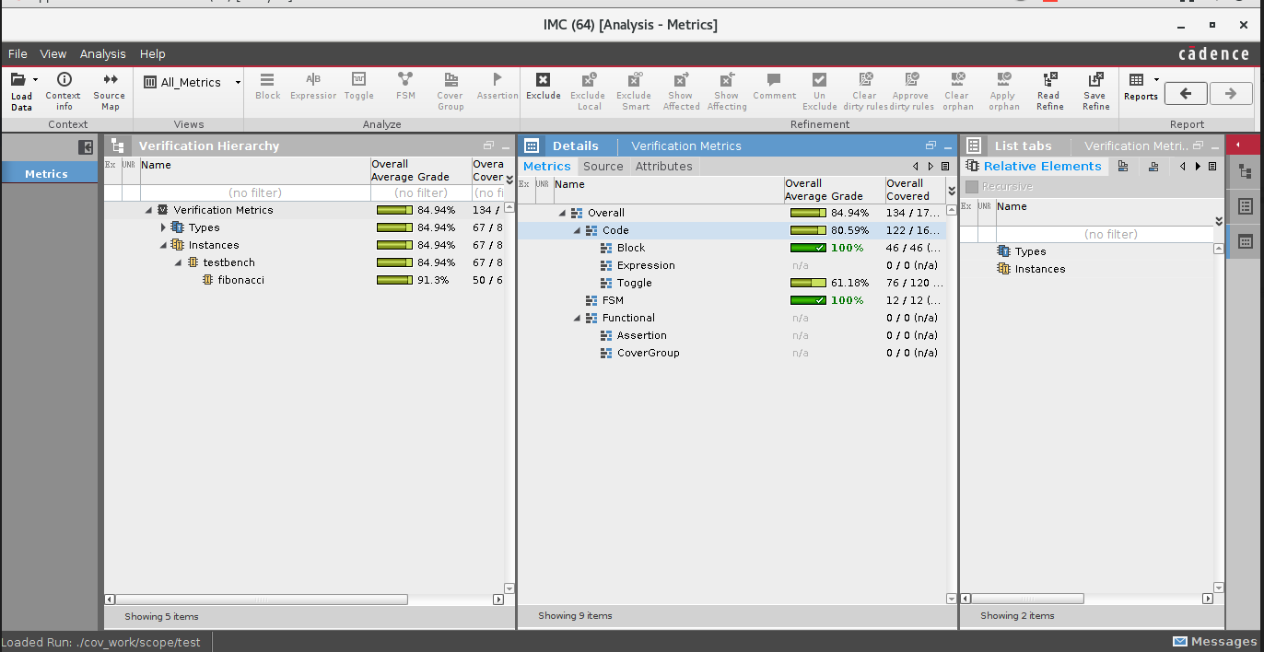

1. Counter

Code:

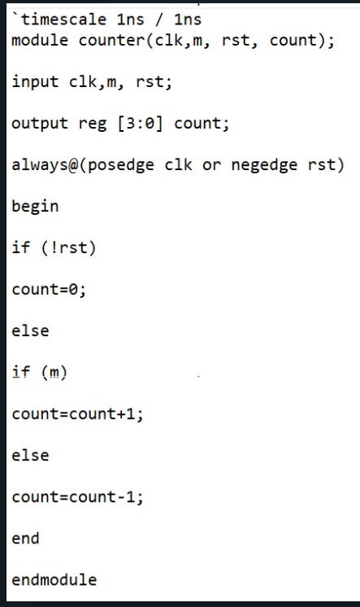

Testbench code:

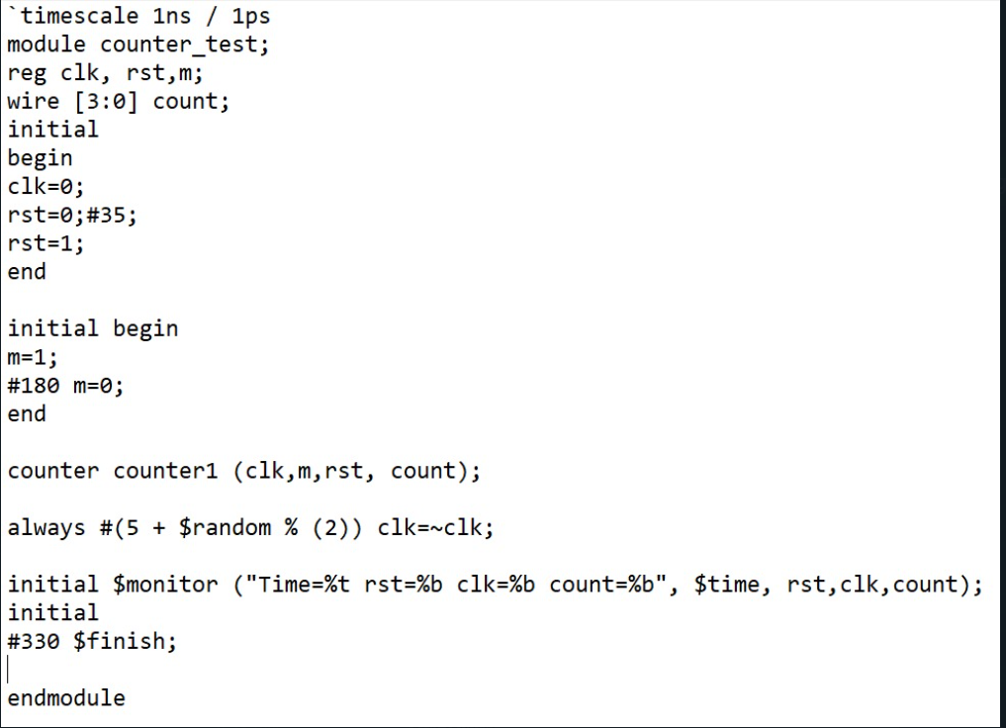

Output:

Waveform

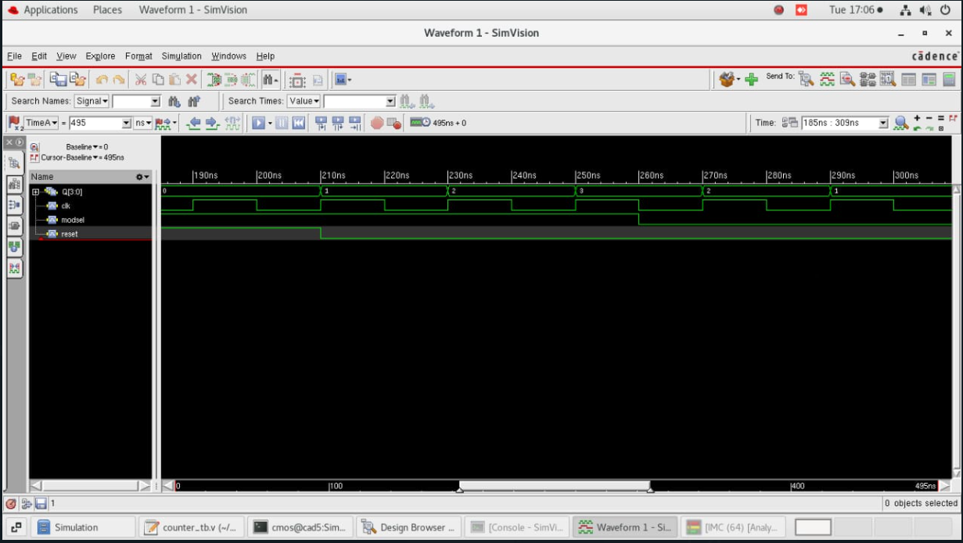

Code coverage:

